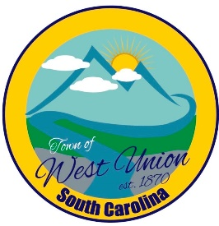
West Union Town Council
Tuesday March 11, 2025
Public Hearing @ 5:30pm
New Fiscal Year 2025-2026 Budget & Water Rates
Regular Meeting @ 6:00pm
West Union Station
1438 W Main St
Call to Order
Certify Quorum
Invocation
Pledge of Allegiance
Minutes
Public Comments –(Each person is limited to 3 minutes to share their opinions, suggestions, complaints, and other thoughts with the council. The speaker must be kind and courteous. Speakers should not be interrupted and refrain from personal attacks.)

Council Comments (The council may reply or suggest topic be put on next meeting agenda )

Reports from committees
Police-
Fire-
Roads/Streets-
Maint. /Water-
Events-
Old Business:
- Second reading of Fiscal Year 2025-2026 Budget
- Second reading of New Water Rates
- Discussion and vote on final contract agreement for rental property (West Union Station)
New Business:
Attorney Update
Adjourn

