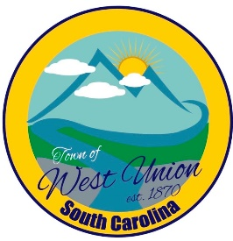
West Union Town Council
Tuesday, July 16, 2024 @ 6:00 pm
West Union Town Hall

Call to Order
Certify Quorum
Invocation
Pledge of Allegiance
Public Comments
Council Comments
Minutes
Reports from committees
Police-
Fire-
Roads/Streets-
Maint. /Water-
Events-
Old Business:
- Discussion and vote on maintenance vehicle
New Business:
- Discussion on pay for being on call
Attorney Update
Adjourn

