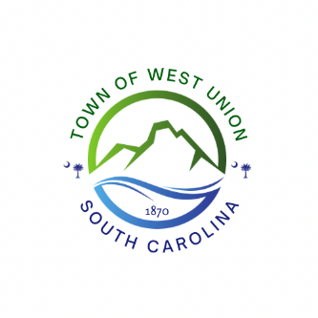
February 3, 2025 @ 5 PM
West Union Town Council
1438 W Main Street
Special Meeting Agenda

Call to order
Certify Quorum
Discussion and vote on new water rates to charge for residential and commercial customers
Adjourn

